**Mongo DB Session Exercise**

**Exercise:**

1. Create a Database named 'MYWall'

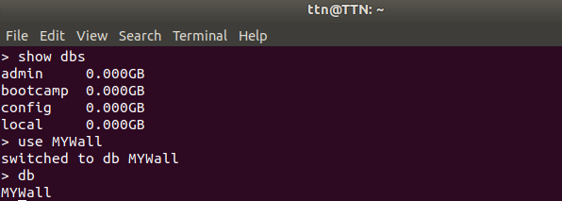

1. Create two collections named 'user and ''post'

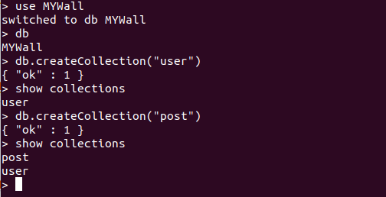

1. Insert some post related information like post_id, title, description , posted_by, comments, created_at etc…

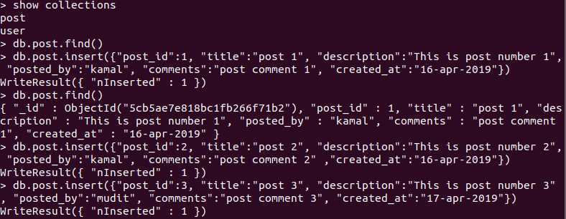

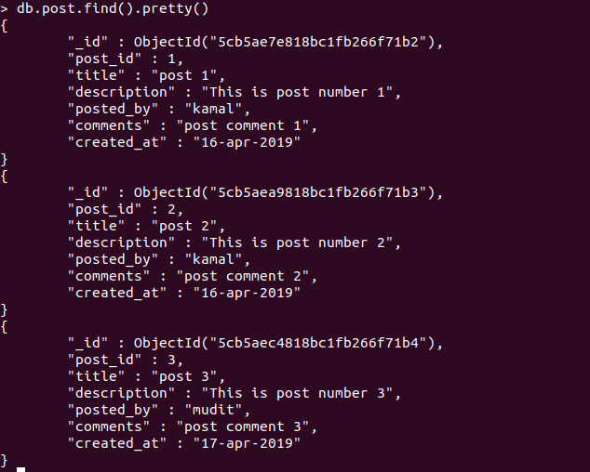

1. Comments should be an array of objects which has comment_id, message, timestamp



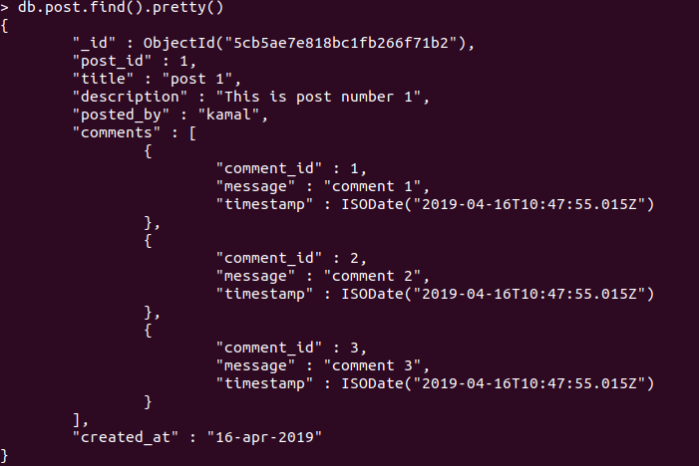

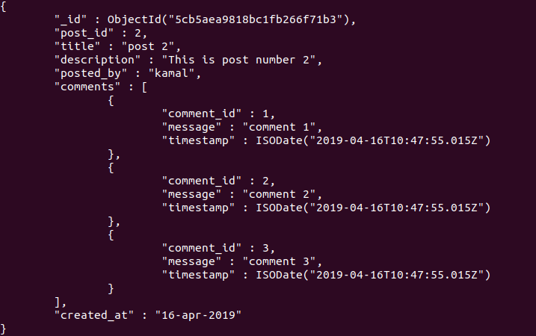

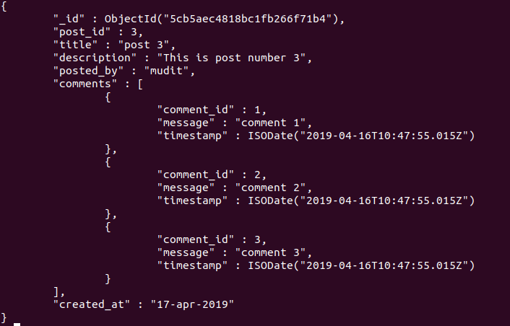

1. Write query to add a new comment for a post



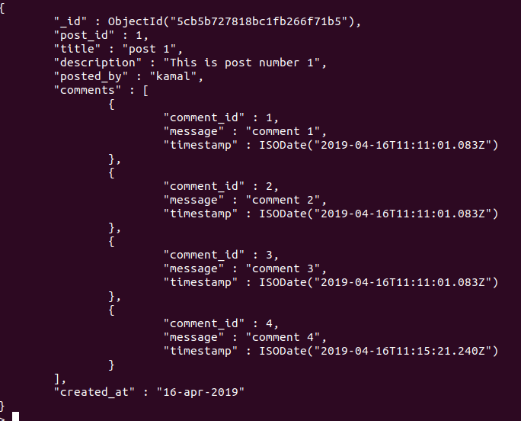

1. Write query to update description of a post



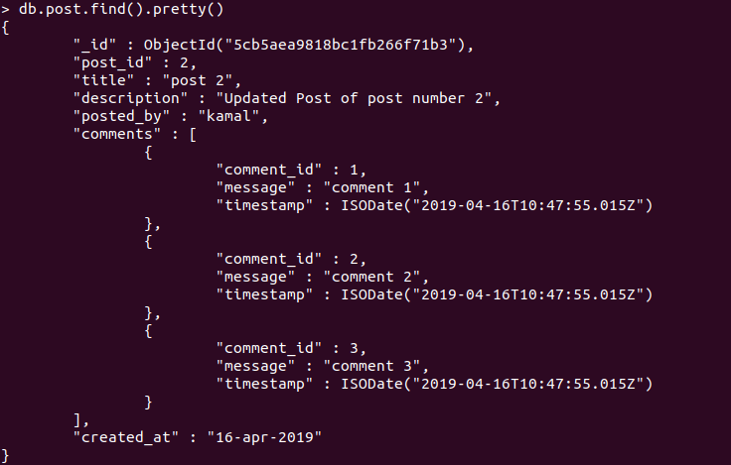

1. Write query to update comment message



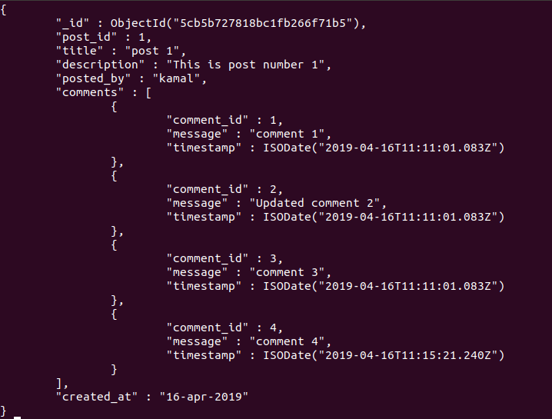

1. Write query to remove a comment



